Jon Janelle

MAT 500

***Chapters 10 and 11 Exercises***

**(10.2A)** The graphs below show the posterior distributions for nu and eta given the prior distributions $ν\sim N\left(μ,τ\right)=N(0, 0.1)$ and $η\sim gamma(0.1, 0.1)$. The posterior probability for model 1 is $P\left(M1 | D\right)=0.746$ and the posterior probability for model 2 is $P\left(M1 | D\right)=0.254$. This shows that model 1 is much more strongly preferred given the data than model 2.

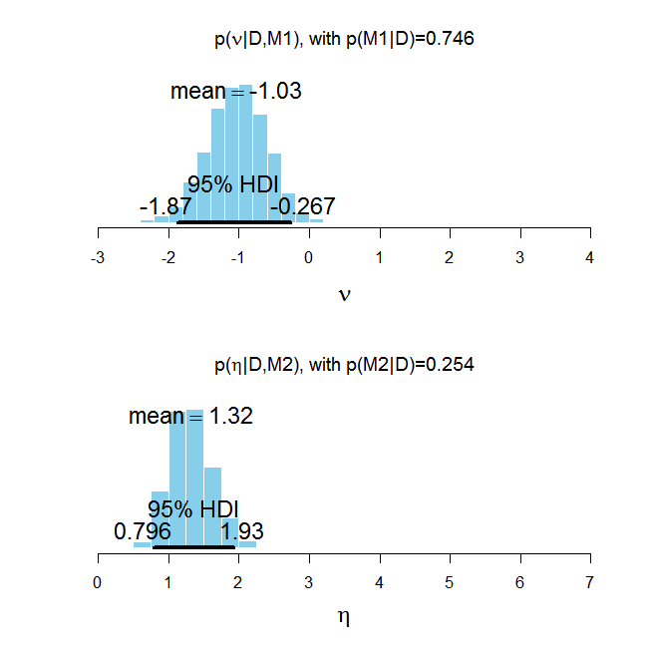

**(10.2B)**

The plot below show the posterior distributions when the prior distributions are changed to $ν\sim N\left(μ,τ\right)=N(1, 1)$ and $η\sim gamma(1, 1)$. In this case, the posterior probability for model 1 is $P\left(M1 | D\right)=0.249$ and the posterior probability for model 2 is $P\left(M1 | D\right)=0.751$. Thus, model 2 is preferred over model 1 given the data.

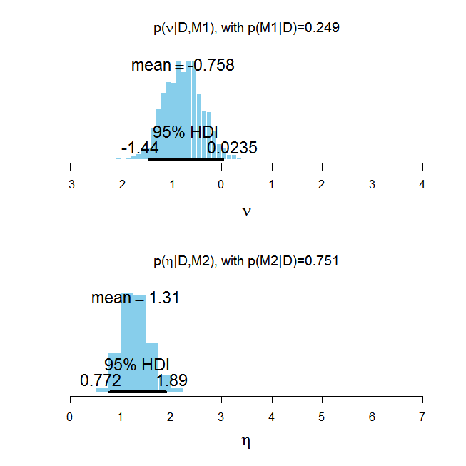

**(10.2C)** The histograms below show, taken from Figure 10.7, show the prior distributions for nu and eta. The left column shows the priors used in part A and the right column shows the priors used in part B. The posterior distributions found in parts A and B show that $ν≈-1$ and $η≈1.3$ are most appropriate given the data. In part A, there is a significant amount of probability mass around $ν=-1$ in the prior distribution. In contrast, there is very little probability mass around $η=1.3$ in the prior distribution for $η$. This causes the sampling chain to get “stuck” model 1, meaning there is significant autocorrelation, which is shown by the part A model index plot below.

A similar scenario arises in part B. The prior distribution for nu is very low around -1, meaning it is not a good fit for the data. The prior distribution for eta is relatively high around 1.3, which means that it will fit the data much better than the prior used in part A. Although more difficult to see in the model index chain plot below, the result is that the chain gets stuck on model 2 and is highly auto-correlated.

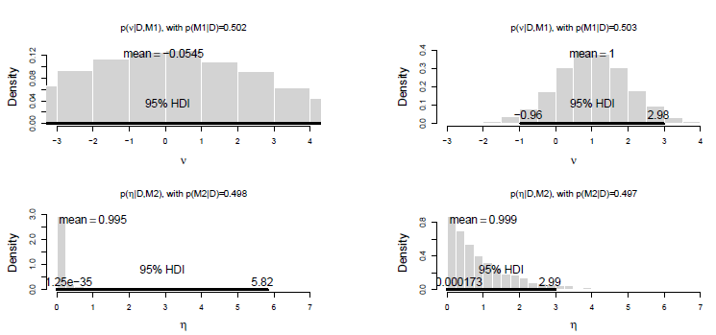

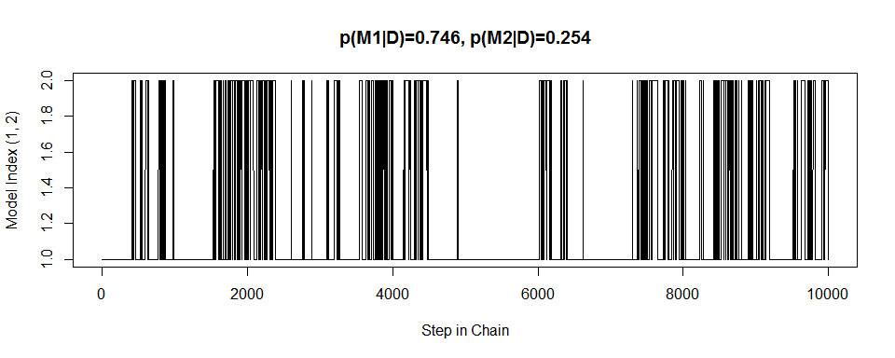

***Model Index Chain from Part A***

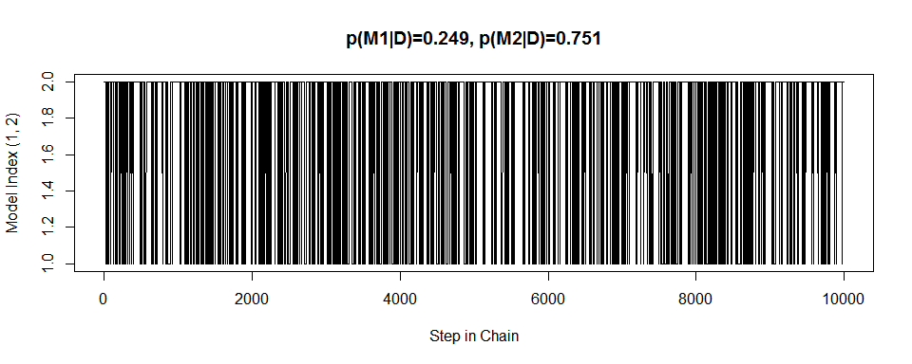

***Model Index Chain from Part B***

**(10.2D)**

More appropriate choices for the prior distributions of nu and eta can be made by first using vague proto-priors to generate posterior distributions for the nu and eta given the data. These posterior distributions, which will fit the data reasonably well, can then be used as prior distributions.

Using Kruschke’s suggestions, the proto-priors $ν\sim N\left(μ,τ\right)=N(0, 0.0001)$ and $η\sim gamma(0.01, 0.01)$. The data will be changed to z = 2 heads in N = 7 flips, which has a similar proportion of heads as the original data, but will result in a wider posteriors due to the smaller sample size. The posterior distributions for nu and eta given these proto-priors are shown in the histograms below. The posterior distribution for nu is approximately normal with mean of -1.09 and precision of $τ≈\frac{1}{{\left(\frac{1.842}{2}\right)}^{2}}= 1.179$. The posterior distribution for eta is approximate gamma with mean 1.3 and standard deviation 0.62, which corresponds to a shape parameter of $s={\left(\frac{1.3}{.62}\right)}^{2}=4.396$ and a rate parameter of $r=\frac{1.3}{{.062}^{2}}=3.382.$ Therefore, the priors $ν\sim N(-1.09, 1.179)$ and $η\sim gamma(4.396, 3.382)$ would be reasonable. The plot of model indices in the chain below shows that using these priors, there is much less autocorrelation and models 1 and 2 are sampled from more evenly.

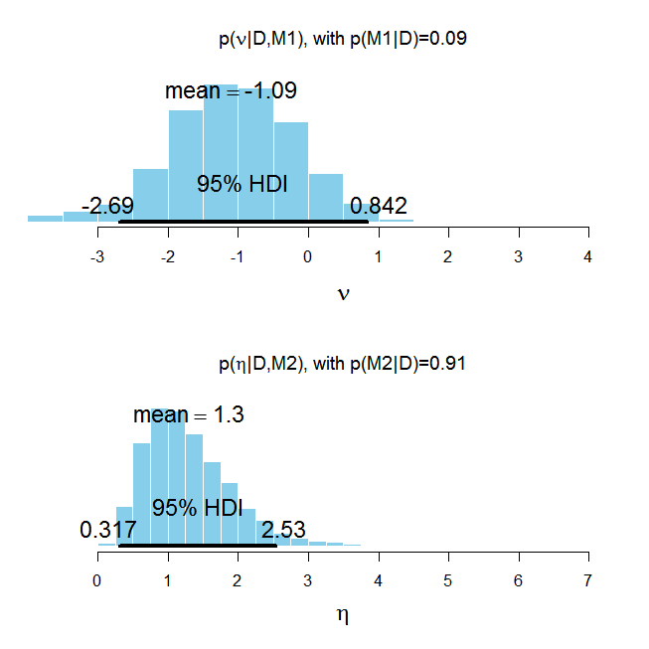

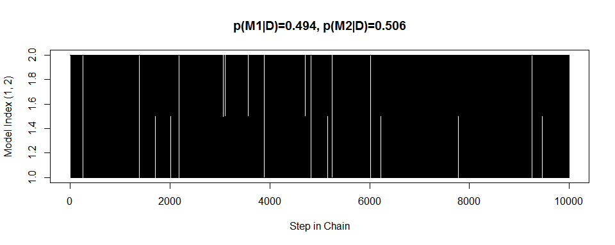

**(10.3A/B)**  The table below shows the mean, standard deviation, gamma shape, and gamma rate parameters that will be used to create pseudo priors. The new assignments made in the pseudo prior specification are also shown.

|  |  |  |  |  |
| --- | --- | --- | --- | --- |
| **Kappa** | **Mean** | **SD** | **Shape = ${\left(\frac{Mean}{SD}\right)}^{2}$** | **Rate = $\frac{Mean}{SD^{2}}$** |
| Kappa0 Model2 | 12.284 | 1.532 | shk0[1] = 64.259 | rak0[1] = 5.231 |
| Kappa1 Model1 | 40.272 | 12.646 | shk[1,2]=10.142 | rak[1,2]=0.252 |
| Kappa2 Model1 | 8.908 | 2.033 | shk[2,2]=19.210 | rak[2,2]=2.156 |
| Kappa3 Model1 | 8.157 | 1.751 | shk[3,2]=21.701 | rak[3,2]=2.660 |
| Kappa4 Model1 | 14.208 | 3.670 | shk[4,2]=14.985 | rak[4,2]=1.055 |

As the histograms below show the, posterior distributions for the kappa values in each model are very similar when the updated pseudo priors are used.

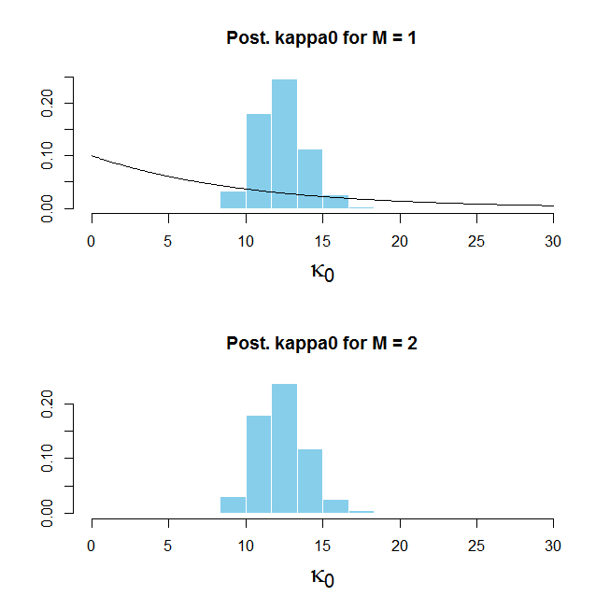

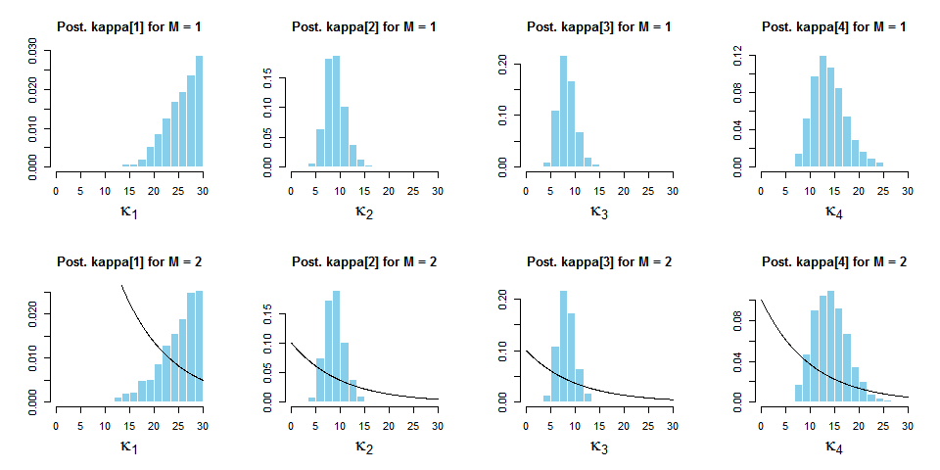

**(10.3C)**

The plot below shows that $P\left(M1 | D\right)=0.659 and P\left(M2 | D\right)=0.341$. From Bayes rule, we know that $P\left(M1 | D\right)=\frac{P\left(D | M1\right)P\left(M1\right)}{P(D)}$ and $P\left(M2 | D\right)=\frac{P\left(D | M2\right)P\left(M2\right)}{P(D)}$. Solving for $P\left(D | M1\right) and P\left(D | M2\right)$ yields $P\left(D | M1\right)=\frac{P\left(M1 | D\right)P\left(D\right)}{P(M1)}$ and $P\left(D | M2\right)=\frac{P\left(M2 | D\right)P\left(D\right)}{P(M2)}$. Therefore, the Bayes factor is

$\frac{P\left(D | M1\right)}{P(D|M1)}=\frac{P\left(M1 | D\right)P\left(M2\right)}{P\left(M2 | D\right)P(M1)}=\frac{\left(0.659\right)\left(.997\right)}{\left(.341\right)(.003)}=642.25.$ This shows that model 1, in which the kappa values are different from each other, is preferred to model 2 about 642 to 1.

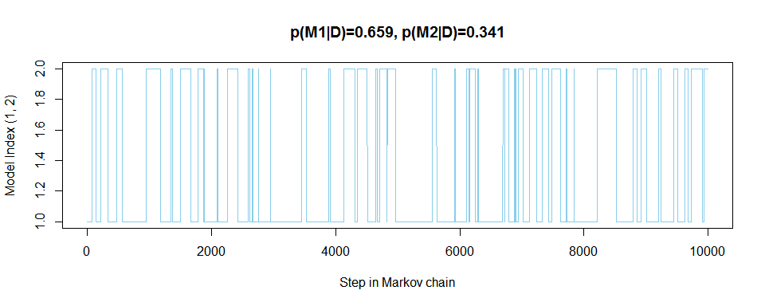

The distributions of the differences in kappa values in model 1 are shown below. Kappa 1 is credibly different from all other kappas, which is shown by the 95% HDIs for the differences in the first row all lying entirely above zero. We cannot conclude that differences exist between the other kappa values. Since not all kappas are equal, the conclusion is that model 1 is preferred.

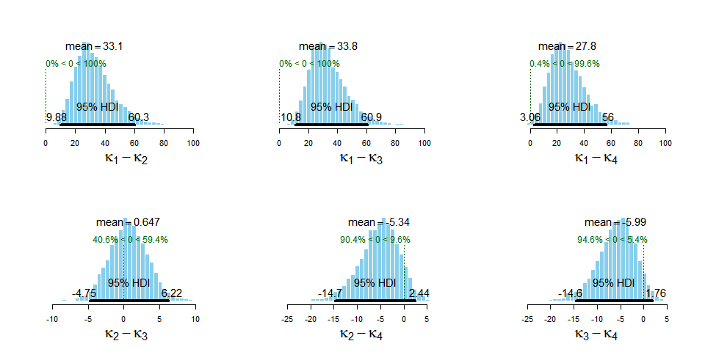

**(11.2A)**

The graph shows $P(z≥8|θ)$ for $.140≤θ≤.145$ for a binomial distribution with N = 26 trials. The red line is drawn at $P(z≥8)=$ 0.025, and the blue line marks $θ=0.144.$ When $θ=0.144$, the probability that $z≥8$ is greater than 0.025, which is shown by the value of the curve at $θ=0.144$ being above 0.025. If theta is less than or equal to approximately 0.143, then the probability that $z≥8$ is less than 0.025.

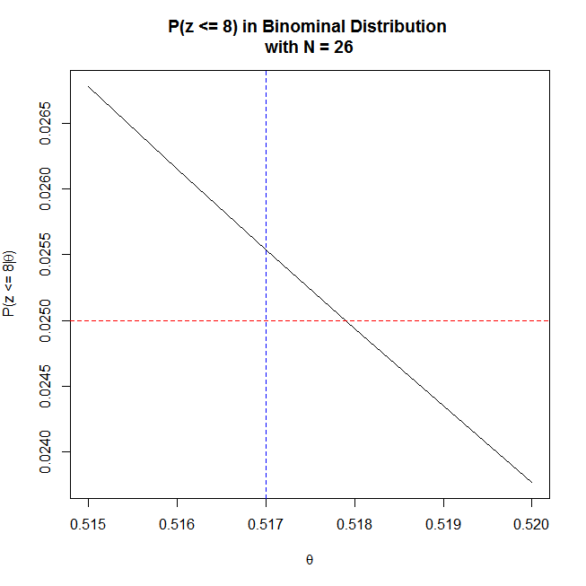**(11.2B)**

The graph shows $P(z≤8|θ)$ for $.515≤θ≤.520$ for a binomial distribution with N = 26 trials. The red line is drawn at $P(z≤8)=$ 0.025, and the blue line marks $θ=0.517.$ When $θ=0.517$, the probability that $z≤8$ is greater than 0.025. If theta is greater than or equal to approximately 0.518, then the probability that $z≤8$ is less than 0.025.

**(11.2C)** Combining the results from the previous two examples, the 95% confidence interval for theta is approximately $0.144≤θ≤0.517$.

**(11.2D)**

If the intention of the experiment was to stop at z = 8 heads, rather than when N = 26, then the experiment should be modeled using a negative binomial distribution instead of a binomial distribution. The tables below show $P(N≤26)$ for $.140≤θ≤.144$ and $P(N≥26)$ for $.490≤θ≤.494$ using a negative binominal distribution. All values were found using the dnbinom function in R. These tables show that the 95% confidence interval for theta is $0.144≤θ≤ .493$ when N = 26 and fixed z = 8**.**

The fact that the confidence interval found with a fixed z = 8 differs from the confidence interval found with a fixed N = 26 demonstrates that an experimenter’s intentions during data collection can change the outcome of the experiment even when the data are seemingly equivalent.

|  |  |
| --- | --- |
| $$θ$$ | $$P(N≤26)$$ |
| .140 | .0220 |
| .141 | .0229 |
| .142 | .0238 |
| .143 | .0248 |
| .144 | .0257 |

|  |  |
| --- | --- |
|  |  |
| .490 | .0273 |
| .491 | .0267 |
| .492 | .0261 |
| .493 | .0255 |
| .494 | .0249 |

**(11.3A)**

Let z be the number of liberals in a sample of N = 46 people and $θ$ be the probability of being a liberal. Using a binomial distribution, the probability of getting 30 or more liberals given the null hypothesis $θ=0.5$ is $P\left(z≥30\right)=$ 0.0270. Assuming $α=0.05$, we fail to reject the null hypothesis and conclude $θ=0.5$.

**(11.3B)**

If the probability of the sample data modeled is modeled using a Poisson distribution, which means the length of the data collection was fixed while N and z can vary, then a test of the null hypothesis $θ=0.5$ yields $P\left(z≥\frac{30}{46}N\right)=0.0209$. We therefore reject the null hypothesis and conclude that $θ>0.5$. This conclusion differs from that in part A, which demonstrates that the way in which an experimenter collects data can influence the conclusions drawn when a frequentist approach is applied.

**(11.3C)**

If N is fixed, z = 26, and N = 39, then $P\left(z≥26\right)=0.0266$. Therefore we fail to reject the null hypothesis $θ=0.5$ when a binomial distribution is assumed.

If a Poisson distribution is used to test $θ=0.5$ given z = 26 and N = 39, then $P\left(z≥\frac{26}{39}N\right)=0.0230.$ In this case, we reject the null and conclude $θ>0.5$.